**WFM Resource Management-Final Document**

**LOGIN PAGE VIEW:**

The Following Screenshot is WFM Resource Management User’s Login ,

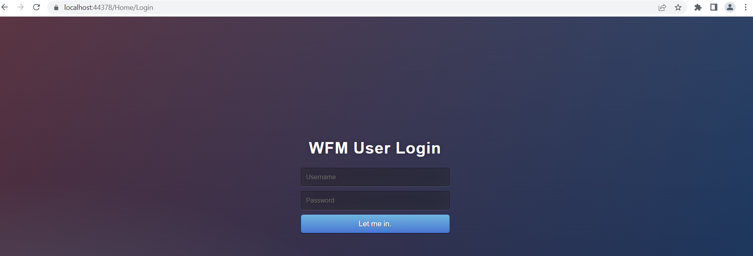

**MANAGER LOGIN VIEW:**

The Manager Login View Page Screenshot ,

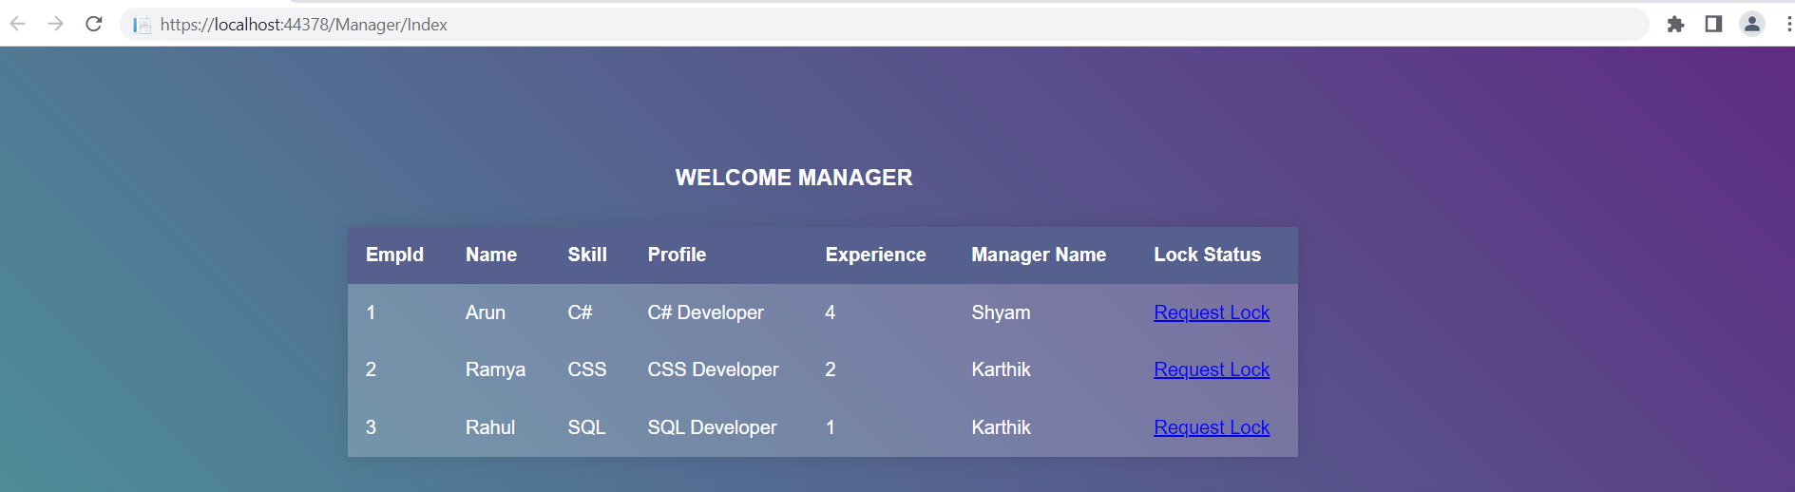

**MANAGER PAGE EDIT VIEW:**

After clicking the Lock request button, the following page will be opened.

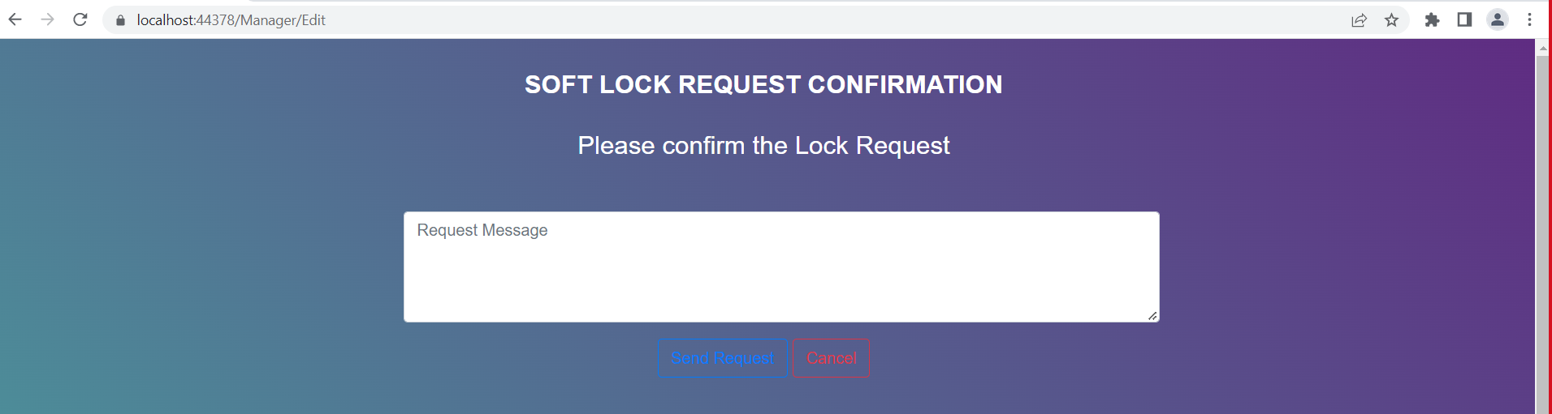

**WFM MANAGER PAGE VIEW:**

The Following Screenshot is WFM Member Page ,

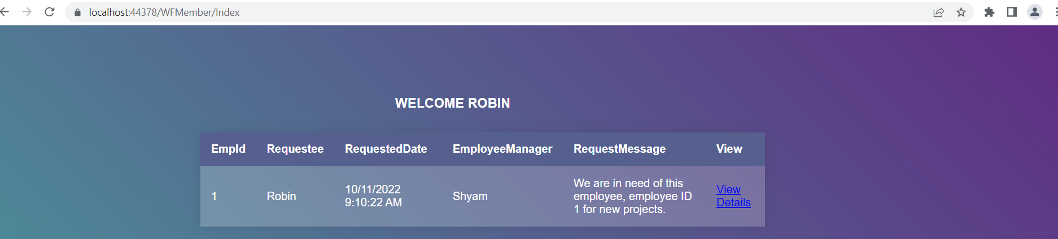

**WFM MEMBER EDIT PAGE VIEW :**

The following Screenshot is WFM Member Edit Page ,

